Oracle Database 10g: Manual
ORACLE
It is a very large multi-user based database management system. Oracle is a relational database management system developed by 'Oracle Corporation'.
Oracle works to efficiently manage its resources, a database of information among the multiple clients requesting and sending data in the network.
It is an excellent database server choice for client/server computing. Oracle supports all major operating systems for both clients and servers, including MSDOS, Windows, UnixWare, OS/2 and most UNIX flavors.

SQL ─ Overview

SQL is a language to operate databases; it includes database creation, deletion, fetching rows, modifying rows, etc. SQL is an ANSI (American National Standards Institute) standard language.
What is SQL? .
SQL is Structured Query Language, which is a computer language for storing, manipulating and retrieving data stored in a relational database.
SQL is the standard language for Relational Database System. All the Relational Database Management Systems (RDMS) like MySQL, MS Access, Oracle, Sybase, Informix, Postgres and SQL Server use SQL as their standard database language.
Why SQL?
SQL is widely popular because it offers the following advantages:
- Allows users to access data in the relational database management systems.
- Allows users to describe the data.
- Allows users to define the data in a database and manipulate that data.
- Allows to embed within other languages using SQL modules, libraries & pre-compilers.
- Allows users to create and drop databases and tables.
- Allows users to create view, stored procedure, functions in a database.
- Allows users to set permissions on tables, procedures and views.
SQL Commands
The standard SQL commands to interact with relational databases are CREATE, SELECT, INSERT, UPDATE, DELETE and DROP. These commands can be classified into the following groups based on their nature:

Command | Description
SELECT  INSERT UPDATE DELETE  MERGE | Retrieves data from the database, enters new rows, changes existing rows, and removes unwanted rows from tables in the database, respectively. Collectively known as data manipulation language (DML).
CREATE  ALTER  DROP  RENAME TRUNCATE COMMENT | Sets up, changes, and removes data structures from tables. Collectively known as data definition language (DDL).
GRANT REVOKE | Gives or removes access rights to both the Oracle database and the structures within it.
COMMIT ROLLBACK SAVEPOINT | Manages the changes made by DML statements. Changes to the data can be grouped together into logical transactions.

SQL ─ RDBMS Concepts
What is RDBMS?
RDBMS stands for Relational Database Management System. RDBMS is the basis for SQL, and for all modern database systems like MS SQL Server, IBM DB2, Oracle, MySQL, and Microsoft Access.
A Relational database management system (RDBMS) is a database management system (DBMS) that is based on the relational model as introduced by E. F. Codd.
What is a table?
The data in an RDBMS is stored in database objects which are called as tables. This table is basically a collection of related data entries and it consists of numerous columns and rows.
Remember, a table is the most common and simplest form of data storage in a relational database. The following program is an example of an EMPLOYEES table:
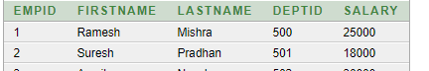

What is a field?
Every table is broken up into smaller entities called fields. The fields in the employees table consist of EMPID, FIRSTNAME, LASTNAME, DEPTID, and SALARY.
A field is a column in a table that is designed to maintain specific information about every record in the table.
What is a Record or a Row?
A record is also called as a row of data is each individual entry that exists in a table. For example, there are 5 records in the above EMPLOYEES table. Following is a single row of data or record in the EMPLOYEES table:
A record is a horizontal entity in a table.

What is a column?
A column is a vertical entity in a table that contains all information associated with a specific field in a table.
For example, a column in the EMPLOYEES table is FISRTNAME, which represents location description and would be as shown below:
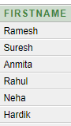

SQL ─ Data Types

Data Type | Description
VARCHAR2(size) | Variable-length character data (A maximum size must be specified: minimum size is 1; maximum size is 4,000.)
CHAR [(size)] | Fixed-length character data of length size bytes (Default and minimum size is 1; maximum size is 2,000.)
NUMBER [(p,s)] | Number having precision p and scale s (The precision is the total number of decimal digits, and the scale is the number of digits to the right of the decimal point.
DATE | Date and time values to the nearest second between January 1, 4712 B.C., and December 31, 9999 A.D.
LONG | Variable-length character data (up to 2 GB)
CLOB | Character data (up to 4 GB
SQL Data Type is an attribute that specifies the type of data of any object. Each column, variable and expression has a related data type in SQL. You can use these data types while creating your tables. You can choose a data type for a table column based on your requirement.

CREATE TABLE Statement

Creating a basic table involves naming the table and defining its columns and each column's data type.
The SQL CREATE TABLE statement is used to create a new table.
Syntax:
The basic syntax of the CREATE TABLE statement is as follows:
CREATE TABLE table_name (
column1 datatype,
column2 datatype,
column3 datatype,
.....
columnN datatype,
PRIMARY KEY (one or more columns)
);

- Creating the EMPLOYEE TABLE
Enter the following SQL command to create the EMPLOYEES table.

create table Employees (
EmpId number,
FirstName varchar(20),
LastName Varchar(20),
EmailId Varchar(50),
Gender char(1),
mobileNo char(10),
DateOfJoining date default sysdate,

DeptId int);
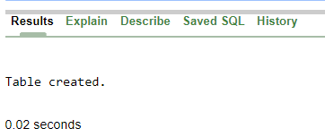

- Describe the Table EMPLOYEES

desc Employees;
Results | Explain | Describe | Saved SQL | History

Object Type | TABLE | Object | EMPLOYEES

Table | Column | Data Type | Length | Precision | Scale | Primary Key | Nullable | Default | Comment
EMPLOYEES | EMPID | Number | - | - | - | - |  | - | -
 | FIRSTNAME | Varchar2 | 20 | - | - | - |  | - | -
 | LASTNAME | Varchar2 | 20 | - | - | - |  | - | -
 | EMAILID | Varchar2 | 50 | - | - | - |  | - | -
 | GENDER | Char | 1 | - | - | - |  | - | -
 | MOBILENO | Char | 10 | - | - | - |  | - | -
 | DATEOFJOINING | Date | 7 | - | - | - |  | sysdate | -
 | DEPTID | Number | - | - | 0 | - |  | - | -
1 - 8

ALTER TABLE

- Altering the table structure

After you create a table, you may need to change the table structure for any of the following reasons:

• You omitted a column.
• Your column definition needs to be changed.
• You need to remove columns.
All changes in the table structure are made by using the ALTER TABLE command,
Followed by a keyword that produces the specific change you want to make.
Four options are available:
Adding Column
Modifying Column
Dropping Column
Renaming Column

- Adding Column

The basic syntax to ADD columns is:
ALTER TABLE tablename
{ADD }( columnname datatype [ {ADD } columnname datatype]);

Alter table Employees add DOB date;

Results | Explain | Describe | Saved SQL | History

Table altered.
0.05 seconds

Desc Employees;
Results | Explain | Describe | Saved SQL | History

Object Type | TABLE | Object | EMPLOYEES

Table | Column | Data Type | Length | Precision | Scale | Primary Key | Nullable | Default | Comment
EMPLOYEES | EMPID | Number | - | - | - | - |  | - | -
 | FIRSTNAME | Varchar2 | 20 | - | - | - |  | - | -
 | LASTNAME | Varchar2 | 20 | - | - | - |  | - | -
 | EMAILID | Varchar2 | 50 | - | - | - |  | - | -
 | GENDER | Char | 1 | - | - | - |  | - | -
 | MOBILENO | Char | 10 | - | - | - |  | - | -
 | DATEOFJOINING | Date | 7 | - | - | - |  | sysdate | -
 | DEPTID | Number | - | - | 0 | - |  | - | -
 | DOB | Date | 7 | - | - | - |  | - | -
1 - 9

DOB added

Alter table Employees add (Salary number (10, 2), pin number);

Results | Explain | Describe | Saved SQL | History

Table altered.
0.00 seconds

Desc Employees;
Results | Explain | Describe | Saved SQL | History

Object Type | TABLE | Object | EMPLOYEES

Table | Column | Data Type | Length | Precision | Scale | Primary Key | Nullable | Default | Comment
EMPLOYEES | EMPID | Number | - | - | - | - |  | - | -
 | FIRSTNAME | Varchar2 | 20 | - | - | - |  | - | -
 | LASTNAME | Varchar2 | 20 | - | - | - |  | - | -
 | EMAILID | Varchar2 | 50 | - | - | - |  | - | -
 | GENDER | Char | 1 | - | - | - |  | - | -
 | MOBILENO | Char | 10 | - | - | - |  | - | -
 | DATEOFJOINING | Date | 7 | - | - | - |  | sysdate | -
 | DEPTID | Number | - | - | 0 | - |  | - | -
 | DOB | Date | 7 | - | - | - |  | - | -
 | SALARY | Number | - | 10 | 2 | - |  | - | -
 | PIN | Number | - | - | - | - |  | - | -
1 - 11

Salary & Pin added
- Modifying Column
The basic syntax to Modify columns is:
ALTER TABLE tablename
{MODIFY }( columnname datatype [ {MODIFY } columnname datatype]);

Alter table Employees modify firstname varchar(30);
Results | Explain | Describe | Saved SQL | History

Table altered.

Desc Employees;

Results | Explain | Describe | Saved SQL | History

Object Type | TABLE | Object | EMPLOYEES

Table | Column | Data Type | Length | Precision | Scale | Primary Key | Nullable | Default | Comment
EMPLOYEES | EMPID | Number | - | - | - | - |  | - | -
 | FIRSTNAME | Varchar2 | 30 | - | - | - |  | - | -
 | LASTNAME | Varchar2 | 20 | - | - | - |  | - | -
 | EMAILID | Varchar2 | 50 | - | - | - |  | - | -
 | GENDER | Char | 1 | - | - | - |  | - | -
 | MOBILENO | Char | 10 | - | - | - |  | - | -
 | DATEOFJOINING | Date | 7 | - | - | - |  | sysdate | -
 | DEPTID | Number | - | - | 0 | - |  | - | -
 | DOB | Date | 7 | - | - | - |  | - | -
 | SALARY | Number | - | 10 | 2 | - |  | - | -
 | PIN | Number | - | - | - | - |  | - | -
1 - 11

Size 30 modified

- Deleting Column
The basic syntax to Drop columns is:

ALTER TABLE tablename
{DROP }( columnname datatype [ {DROP } columnname datatype]);

Alter table Employees drop column pin;

Results | Explain | Describe | Saved SQL | History

Table dropped.
0.48 seconds

Desc Employees;

Results | Explain | Describe | Saved SQL | History

Object Type | TABLE | Object | EMPLOYEES

Table | Column | Data Type | Length | Precision | Scale | Primary Key | Nullable | Default | Comment
EMPLOYEES | EMPID | Number | - | - | - | - |  | - | -
 | FIRSTNAME | Varchar2 | 30 | - | - | - |  | - | -
 | LASTNAME | Varchar2 | 20 | - | - | - |  | - | -
 | EMAILID | Varchar2 | 50 | - | - | - |  | - | -
 | GENDER | Char | 1 | - | - | - |  | - | -
 | MOBILENO | Char | 10 | - | - | - |  | - | -
 | DATEOFJOINING | Date | 7 | - | - | - |  | sysdate | -
 | DEPTID | Number | - | - | 0 | - |  | - | -
 | DOB | Date | 7 | - | - | - |  | - | -
 | SALARY | Number | - | 10 | 2 | - |  | - | -
1 - 10

Pin deleted

- Renaming Column
The basic syntax to Rename columns is:

ALTER TABLE tablename
{RENAME}( columnname to columnname);

Alter table Employees rename column Dateofjoining to DOJ;
Results | Explain | Describe | Saved SQL | History

Table altered.
0.02 seconds

Desc Employees;

Results | Explain | Describe | Saved SQL | History

Object Type | TABLE | Object | EMPLOYEES

Table | Column | Data Type | Length | Precision | Scale | Primary Key | Nullable | Default | Comment
EMPLOYEES | EMPID | Number | - | - | - | - |  | - | -
 | FIRSTNAME | Varchar2 | 30 | - | - | - |  | - | -
 | LASTNAME | Varchar2 | 20 | - | - | - |  | - | -
 | EMAILID | Varchar2 | 50 | - | - | - |  | - | -
 | GENDER | Char | 1 | - | - | - |  | - | -
 | MOBILENO | Char | 10 | - | - | - |  | - | -
 | DOJ | Date | 7 | - | - | - |  | sysdate | -
 | DEPTID | Number | - | - | 0 | - |  | - | -
 | DOB | Date | 7 | - | - | - |  | - | -
 | SALARY | Number | - | 10 | 2 | - |  | - | -
1 - 10

Rename Dateofjoining to DOJ

DROP TABLE

The DROP TABLE command permanently deletes a table (and thus its data) from the database.
Syntax:
DROP TABLE tablename ;

drop table Employees;

TRUNCAT TABLE
Removes all rows from a table, leaving the table empty and the table structure intact.
Syntax:
TRUNCATE TABLE table name;
;

truncate table Employees;

RENAME TABLE

To rename a table , you use the following Oracle RENAME table statement as follows:
Syntax:
RENAME Table_name TO new_name ;

;

In the rename table statement:
- First specify the name of the existing table which you want to rename.
- Second specify the new table name.

Rename Employees to EmployeesOne;
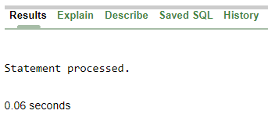

Rename EmployeesOne to Employees;

Constraints
The Oracle server uses constraints to prevent invalid data entry into tables.
You can use constraints to do the following:
  - Is a rule to which data must conform
  - Constraints name are optional
  - Can be added a Column level or Table level
  - Can be enabled/disabled/dropped

Constraint | Description
NOT NULL | Specifies that the column cannot contain a null value
UNIQUE | Specifies a column or combination of columns whose values must be unique for all rows in the table
PRIMARY KEY | Uniquely identifies each row of the table
CHECK | Specifies a condition that must be true
FOREIGN KEY | Establishes and enforces a foreign key relationship between the column and a column of the referenced table

For Existing Table The ALTER TABLE command can also be used to add /drop table constraints.
the syntax would be:
ALTER TABLE tablename
ADD /DROP constraint [ ADD / DROP constraint ]
NOT NULL Constraint

Example :
Create table Sample1(
Col1 number constraint Sample1_Col1_nn not null,

Col2 number not null);

(Col1: if we will not give name oracle server automatically assign the name, but it will better if you will pass a name by yourself, because you can enabled/disabled/dropped constraint easily.)
(Col2: Directly write constraint name)
Results | Explain | Describe | Saved SQL | History

Table created.
0.14 seconds

desc Sample1
Results | Explain | Describe | Saved SQL | History

Object Type | TABLE | Object | SAMPLE1

Table | Column | Data Type | Length | Precision | Scale | Primary Key | Nullable | Default | Comment
SAMPLE1 | COL1 | Number | - | - | - | - | - | - | -
 | COL2 | Number | - | - | - | - | - | - | -
1 - 2

Both column are NOT NULL
If you want to pass the existing column or existing table which you have already created table name Employees.
Here Firstname column we want to pass not null constraint by ALTER command.
alter table Employees modify firstname varchar2(30)

Constraint Employees_firstname_nn not null;
Results |  | Explain | Describe | Saved SQL | History

Table altered.
0.01 seconds

desc Employees;

Results | Explain | Describe | Saved SQL | History

Object Type | TABLE | Object | EMPLOYEES

Table | Column | Data Type | Length | Precision | Scale | Primary Key | Nullable | Default | Comment
EMPLOYEES | EMPID | Number | - | - | - | - |  | - | -
 | FIRSTNAME | Varchar2 | 30 | - | - | - | - | - | -
 | LASTNAME | Varchar2 | 20 | - | - | - |  | - | -
 | EMAILID | Varchar2 | 50 | - | - | - |  | - | -
 | GENDER | Char | 1 | - | - | - |  | - | -
 | MOBILENO | Char | 10 | - | - | - |  | - | -
 | DOJ | Date | 7 | - | - | - |  | sysdate | -
 | DEPTID | Number | - | - | 0 | - |  | - | -
 | DOB | Date | 7 | - | - | - |  | - | -
 | SALARY | Number | - | 10 | 2 | - |  | - | -
1 - 10

Firstname is NOT NULL

UNIQUE Constraint

The UNIQUE specification creates a unique index in the respective attribute. Use
it to avoid duplicated values in a column.
Example :
Create table Sample1(
Col1 number constraint Sample1_Col1_un unique,
Col2 number ,
Col3 number unique,
Constraint Sample1_unique unique(col2) );

Results | Explain | Describe | Saved SQL | History

Table created.
0.14 seconds

Results | Explain | Describe | Saved SQL | History

Object Type | TABLE | Object | SAMPLE1

Table | Column | Data Type | Length | Precision | Scale | Primary Key | Nullable | Default | Comment
SAMPLE1 | COL1 | Number | - | - | - | - |  | - | -
 | COL2 | Number | - | - | - | - |  | - | -
 | COL3 | Number | - | - | - | - |  | - | -
1 - 3

In our Employees table { EmailId } pass unique constraint by ALTER command.

alter table Employees add constrant Employees_Email_un unique(EmailId);

Results | Explain | Describe | Saved SQL | History

Table altered.
0.05 seconds

desc Employees;
Results | Explain | Describe | Saved SQL | History

Object Type | TABLE | Object | EMPLOYEES

Table | Column | Data Type | Length | Precision | Scale | Primary Key | Nullable | Default | Comment
EMPLOYEES | EMPID | Number | - | - | - | - |  | - | -
 | FIRSTNAME | Varchar2 | 30 | - | - | - | - | - | -
 | LASTNAME | Varchar2 | 20 | - | - | - |  | - | -
 | EMAILID | Varchar2 | 50 | - | - | - |  | - | -
 | GENDER | Char | 1 | - | - | - |  | - | -
 | MOBILENO | Char | 10 | - | - | - |  | - | -
 | DOJ | Date | 7 | - | - | - |  | sysdate | -
 | DEPTID | Number | - | - | 0 | - |  | - | -
 | DOB | Date | 7 | - | - | - |  | - | -
 | SALARY | Number | - | 10 | 2 | - |  | - | -
1 - 10

Primary Key Constraint

A primary key is a field in a table which uniquely identifies each row/record in a database table. Primary keys must contain unique values. A primary key column cannot have NULL values.
Here is the syntax to define the ID attribute as a primary key in a CUSTOMERS table.
CREATE TABLE CUSTOMERS(
ID INT PRIMARY KEY,
NAME VARCHAR (20),
AGE DATEI ,

ADDRESS CHAR (25));
Or we can write Multiple column.
PRIMARY KEY (ID ,NAME));
Results | Explain | Describe | Saved SQL | History

Table created.
0.02 seconds
desc Customers;

Results | Explain | Describe | Saved SQL | History

Object Type | TABLE | Object | CUSTOMERS

Table | Column | Data Type | Length | Precision | Scale | Primary Key | Nullable | Default | Comment
CUSTOMERS | ID | Number | - | - | - | 1 | - | - | -
 | NAME | Varchar2 | 20 | - | - | - |  | - | -
 | AGE | Number | - | - | - | - |  | - | -
1 - 3

ID is PRIMARY KEY
Delete Primary Key You can clear the primary key constraints from the table with the syntax given below.

ALTER TABLE CUSTOMERS DROP PRIMARY KEY ;
Results | Explain | Describe | Saved SQL | History

Table altered.
0.00 seconds

desc Customers;
Results | Explain | Describe | Saved SQL | History

Object Type | TABLE | Object | CUSTOMERS

Table | Column | Data Type | Length | Precision | Scale | Primary Key | Nullable | Default | Comment
CUSTOMERS | ID | Number | - | - | - | - |  | - | -
 | NAME | Varchar2 | 20 | - | - | - |  | - | -
 | AGE | Number | - | - | - | - |  | - | -
1 - 3
Delete Primary Key

To create a PRIMARY KEY constraint on the multiple column when the CUSTOMERS table already exists, use the following SQL syntax:
ALTER TABLE CUSTOMERS ADD CONSTRAINT CUSTOMERS_NAME_PK PRIMARY KEY (ID, NAME);

Results | Explain | Describe | Saved SQL | History

Table altered.

desc Customers;

Results | Explain | Describe | Saved SQL | History

Object Type | TABLE | Object | CUSTOMERS

Table | Column | Data Type | Length | Precision | Scale | Primary Key | Nullable | Default | Comment
CUSTOMERS | ID | Number | - | - | - | 1 | - | - | -
 | NAME | Varchar2 | 20 | - | - | 2 | - | - | -
 | AGE | Number | - | - | - | - |  | - | -
1 - 3

Primary Key ID & NAME
CHECK Constraint

The CHECK Constraint enables a condition to check the value being entered into a record. If the condition evaluates to false, the record violates the constraint and isn't entered the table.
Example the following program creates a new table called CUSTOMERS and adds three columns. Here, we add a CHECK with AGE column, so that you cannot have any CUSTOMER who is below 18 years.
CREATE TABLE CUSTOMERS(
ID INT ,
NAME VARCHAR (20),

AGE INT CHECK (AGE >= 18));
Results | Explain | Describe | Saved SQL | History

Object Type | TABLE | Object | CUSTOMERS

Table | Column | Data Type | Length | Precision | Scale | Primary Key | Nullable | Default | Comment
CUSTOMERS | ID | Number | - | - | - | - |  | - | -
 | NAME | Varchar2 | 20 | - | - | - |  | - | -
 | AGE | Number | - | - | 0 | - |  | - | -
1 - 3

If the CUSTOMERS table has already been created, then to add a CHECK constraint to AGE column, you would write a statement like the one given below.
ALTER TABLE CUSTOMERS
MODIFY AGE INT CHECK (AGE >= 18 );
OR
ALTER TABLE CUSTOMERS
MODIFY AGE INT CONSTRAINT CUSTOMERS_AGE_CK CHECK (AGE >= 18);

Results | Explain | Describe | Saved SQL | History

Table altered.
0.01 seconds
You can also use the following syntax, which supports naming the constraint in multiple columns as well:
ALTER TABLE CUSTOMERS

ADD CONSTRAINT CUSTOMERS_AGE_CK CHECK (AGE >= 18);

Results | Explain | Describe | Saved SQL | History

Table altered.
0.01 second

DROP a CHECK Constraint To drop a CHECK constraint, use the following SQL syntax.
ALTER TABLE CUSTOMERS

DROP CONSTRAINT CUSTOMERS_AGE_CK;
Results | Explain | Describe | Saved SQL | History

Table dropped.
0.00 seconds

Our existing TABLE Employees

Check Gender “M” or “F”

ALTER TABLE EMPLOYEES
ADD CONSTRAINT EMP_GENDER_CHECK CHECK(GENDER IN(‘M’,’F’));

Results |  | Explain | Describe | Saved SQL | History

Table altered.
0.02 seconds
Foreign Key Constraint

A foreign key is a key used to link two tables together. This is sometimes also called as a referencing key.
A Foreign Key is a column or a combination of columns whose values match a Primary Key in a different table.
The relationship between 2 tables matches the Primary Key in one of the tables with a Foreign Key in the second table.
If a table has a primary key defined on any field(s), then you cannot have two records having the same value of that field(s).

Example Consider the structure of the following two tables.
CUSTOMERS Table:
CREATE TABLE CUSTOMERS(
CUSTID INT PRIMARY KEY,

NAME VARCHAR (20));
Results | Explain | Describe | Saved SQL | History

Object Type | TABLE | Object | CUSTOMERS

Table | Column | Data Type | Length | Precision | Scale | Primary Key | Nullable | Default | Comment
CUSTOMERS | CUSTID | Number | - | - | - | 1 | - | - | -
 | NAME | Varchar2 | 20 | - | - | - |  | - | -
1 - 2

ORDERS Table
CREATE TABLE ORDERS (
ID INT PRIMARY KEY,
CUSTOMER_ID INT references CUSTOMERS (CUSTID),

AMOUNT NUMBER);
Results | Explain | Describe | Saved SQL | History

Object Type | TABLE | Object | ORDERS

Table | Column | Data Type | Length | Precision | Scale | Primary Key | Nullable | Default | Comment
ORDERS | ID | Number | - | - | - | 1 | - | - | -
 | CUSTOMERID | Number | - | - | 0 | - |  | - | -
 | AMOUNT | Number | - | - | - | - |  | - | -
1 - 3

If the ORDERS table has already been created and the foreign key has not yet been set, the use the syntax for specifying a foreign key by altering a table.
ALTER TABLE ORDERS
ADD CONSTRANT ORDER_FK FOREIGN KEY (CustomerID)

REFERENCES CUSTOMERS (CUSTID);
REFERENCES identifies the table and column in the parent table.
• ON DELETE CASCADE indicates that when the row in the parent table is deleted, the dependent rows in the child table are also deleted.
• ON DELETE SET NULL converts foreign key values to null when the parent value is removed.
DROP a FOREIGN KEY Constraint
To drop a FOREIGN KEY constraint, use the following SQL syntax.

ALTER TABLE ORDERS DROP FOREIGN KEY;
Managing the constraints
Viewing Constraints

Adding Constraints

Disabling Constraints
Constraints

Enabling Constraints
Constraints

Dropping Constraints

desc user_constraints;

Object Type | VIEW | Object | USER_CONSTRAINTS

Table | Column | Data Type | Length | Precision | Scale | Primary Key | Nullable | Default | Comment
USER_CONSTRAINTS | OWNER | Varchar2 | 30 | - | - | - | - | - | Owner of the table
 | CONSTRAINT_NAME | Varchar2 | 30 | - | - | - | - | - | Name associated with constraint definition
 | CONSTRAINT_TYPE | Varchar2 | 1 | - | - | - |  | - | Type of constraint definition
 | TABLE_NAME | Varchar2 | 30 | - | - | - | - | - | Name associated with table with constraint definition
 | SEARCH_CONDITION | Long | 0 | - | - | - |  | - | Text of search condition for table check
 | R_OWNER | Varchar2 | 30 | - | - | - |  | - | Owner of table used in referential constraint
 | R_CONSTRAINT_NAME | Varchar2 | 30 | - | - | - |  | - | Name of unique constraint definition for referenced table
 | DELETE_RULE | Varchar2 | 9 | - | - | - |  | - | The delete rule for a referential constraint
 | STATUS | Varchar2 | 8 | - | - | - |  | - | Enforcement status of constraint - ENABLED or DISABLED
 | DEFERRABLE | Varchar2 | 14 | - | - | - |  | - | Is the constraint deferrable - DEFERRABLE or NOT DEFERRABLE
 | DEFERRED | Varchar2 | 9 | - | - | - |  | - | Is the constraint deferred by default - DEFERRED or IMMEDIATE
 | VALIDATED | Varchar2 | 13 | - | - | - |  | - | Was this constraint system validated? - VALIDATED or NOT VALIDATED
 | GENERATED | Varchar2 | 14 | - | - | - |  | - | Was the constraint name system generated? - GENERATED NAME or USER NAME
 | BAD | Varchar2 | 3 | - | - | - |  | - | Creating this constraint should give ORA-02436. Rewrite it before 2000 AD.
 | RELY | Varchar2 | 4 | - | - | - |  | - | If set, this flag will be used in optimizer
 | LAST_CHANGE | Date | 7 | - | - | - |  | - | The date when this column was last enabled or disabled
 | INDEX_OWNER | Varchar2 | 30 | - | - | - |  | - | The owner of the index used by the constraint
 | INDEX_NAME | Varchar2 | 30 | - | - | - |  | - | The index used by the constraint
 | INVALID | Varchar2 | 7 | - | - | - |  | - | -
 | VIEW_RELATED | Varchar2 | 14 | - | - | - |  | - | -
1-20

To see what all constraints are in our EMPLOYEES table.
select constraint_name,constraint_type from user_constraints where table_name='EMPLOYEES';

Results | Explain | Describe | Saved SQL | History

CONSTRAINT_NAME | CONSTRAINT_TYPE
EMPLOYEES_FIRSTNAME_NN | C
EMPLOYEES_EMAIL_UN | U
EMP_GENDER_CHECK | C
EMPLOYEES_EMPID_PK | P
4 rows returned in 0.00 seconds |  | CSV Export
C represents Not Null and Check.
To see the Columns wise .
select constraint_name,column_name from user_cons_columns where table_name='EMPLOYEES'

Results | Explain | Describe | Saved SQL | History

CONSTRAINT_NAME | COLUMN_NAME
EMPLOYEES_FIRSTNAME_NN | FIRSTNAME
EMPLOYEES_EMAIL_UN | EMAILID
EMP_GENDER_CHECK | GENDER
EMPLOYEES_EMPID_PK | EMPID
4 rows returned in 0.02 seconds |  | CSV Export

Disable Constraints
alter table Employees disable constraint Emp_Gender_check;

Enable Constraints
alter table Employees enable constraint Emp_Gender_check;

Drop Constrains
alter table Employees Drop constraint Emp_Gender_check;

Results | Explain | Describe | Saved SQL | History

Table altered.
0.00 seconds

Data manipulation language (DML)

  - SELECT
  - INSERT
  - UPDATE
  - DELETE
• A DML statement is executed when you:
- Add new rows to a table
- Modify existing rows in a table
- Remove existing rows from a table
• A transaction consists of a collection of DML statements that form a logical unit of work.
The learning objectives for this lab are:
- To know how to insert, update and delete data from within a table
- To learn how to retrieve data from a table using the SELECT statement
INSERT

The SQL INSERT INTO Statement is used to add new rows of data to a table in the database.
Syntax:
There are two basic syntaxes of the INSERT INTO statement which are shown below.
INSERT INTO TABLE_NAME (column1, column2, column3,...columnN)]
VALUES (value1, value2, value3,...valueN);

Here, column1, column2, column3,...columnN are the names of the columns in the table into which you want to insert the data.
You may not need to specify the column(s) name in the SQL query if you are adding values for all the columns of the table. But make sure the order of the values is in the same order as the columns in the table.
The SQL INSERT INTO syntax will be as follows:
INSERT INTO TABLE_NAME VALUES (value1, value2, value3,...valueN);

[Our existing Employees Table we put at least 10 record]
- Character data within single quotation (‘ ‘) mark.
- Date put either (sysdate) system date or new date.
Insert into Employees values(001,'Ramesh','Mishra','rameshm@gmail.com',
'M','2589636542',sysdate,500,'27-Aug-1971',15000);
Results | Explain | Describe | Saved SQL | History

1 row(s) inserted.
0.00 seconds

insert into Employees values(002,'Suresh','Pradhan','sp007@gmail.com',
'M','8722567598','20-Jan-2009',501,'23-July-1989',18000);
Results | Explain | Describe | Saved SQL | History

1 row(s) inserted.
0.00 seconds

insert into Employees values(003,'Anmita','Nayak','anayak@gmail.com',
'F','9435862145','18-Jan-2019',502,'13-Aug-1998',30000);
Results | Explain | Describe | Saved SQL | History

1 row(s) inserted.
0.00 seconds

insert into Employees values(004,'Rahul','Bajaj','rb001@gmail.com',
'M','9234856127',sysdate,503,'12-July-1995',20000);
Results | Explain | Describe | Saved SQL | History

1 row(s) inserted.
0.00 seconds

insert into Employees values(005,'Neha','Agrawal','nagra12@gmail.com',
Results | Explain | Describe | Saved SQL | History
'F','7236518925','2-Jan-2019',504,'18-Dec-1997',25000);

1 row(s) inserted.

insert into Employees values(006,'Hardik','Pandia','Hpcri@rediffmail.com',
'M','9643258768','5-April-2018',505,'5-march-1990',21000);
Results | Explain | Describe | Saved SQL | History

1 row(s) inserted.

insert into Employees values(007,'Sapna','Sharma','sharmas@Yahoo.com',
'F','6958678541','10-May-2017',506,'17-Nov-1986',19000);
Results | Explain | Describe | Saved SQL | History

1 row(s) inserted.
0.00 seconds

insert into Employees values(008,'Rohit','Kumar','rohitku@gmail.com',
'M','8452387624','28-Feb-2016',507,'16-Sep-1994',26000);
Results | Explain | Describe | Saved SQL | History

1 row(s) inserted.
0.00 seconds

insert into Employees values(009,'Khushi','Agrawal','kagrawal@gmail.com',
'F','2569457964','17-July-2015',508,'13-Oct-1997',23000);
Results | Explain | Describe | Saved SQL | History

1 row(s) inserted.
0.00 seconds

insert into Employees values(010,'Ganesh','Sahu','sahuganesh@gmail.com',
'M','1348976524','29-June-2019',509,'25-Sep-1983',24000);
Results | Explain | Describe | Saved SQL | History

1 row(s) inserted.
0.00 seconds

select * from Employees;
Results | Explain | Describe | Saved SQL | History

EMPID | FIRSTNAME | LASTNAME |  | EMAILID | GENDER | MOBILENO | DOJ | DEPTID | DOB | SALARY
1 | Ramesh | Mishra |  | rameshm@gmail.com | M | 2589636542 | 27-APR-20 | 500 | 27-AUG-71 | 15000
2 | Suresh | Pradhan |  | sp007@gmail.com | M | 8722567598 | 20-JAN-09 | 501 | 23-JUL-89 | 18000
3 | Anmita | Nayak |  | anayak@gmail.com | F | 9435862145 | 18-JAN-19 | 502 | 13-AUG-98 | 30000
4 | Rahul | Bajaj |  | rb001@gmail.com | M | 9234856127 | 27-APR-20 | 503 | 12-JUL-95 | 20000
5 | Neha | Agrawal |  | nagra12@gmail.com | F | 7236518925 | 02-JAN-19 | 504 | 18-DEC-97 | 25000
6 | Hardik | Pandia |  | Hpcri@rediffmail.com | M | 9643258768 | 05-APR-18 | 505 | 05-MAR-90 | 21000
7 | Sapna | Sharma |  | sharmas@Yahoo.com | F | 6958678541 | 10-MAY-17 | 506 | 17-NOV-86 | 19000
8 | Rohit | Kumar |  | rohitku@gmail.com | M | 8452387624 | 28-FEB-16 | 507 | 16-SEP-94 | 26000
9 | Khushi | Agrawal |  | kagrawal@gmail.com | F | 2569457964 | 17-JUL-15 | 508 | 13-OCT-97 | 23000
10 | Ganesh | Sahu |  | sahuganesh@gmail.com | M | 1348976524 | 29-JUN-19 | 509 | 25-SEP-83 | 24000
10 rows returned in 0.00 seconds |  |  |  | CSV Export

Gender is Check constraints M or F, If we write other alphabet its display:
Results | Explain | Describe | Saved SQL | History

ORA-02290: check constraint (SYSTEM.EMP_GENDER_CHECK) violated

EMPID is Primary Key it cannot be duplicate. If we write same EMPID its display:
Results | Explain | Describe | Saved SQL | History

ORA-00001: unique constraint (SYSTEM.EMPLOYEES_EMPID_PK) violated

0.02 seconds

UPDATE

The SQL UPDATE Query is used to modify the existing records in a table. You can use the WHERE clause with the UPDATE query to update the selected rows, otherwise all the rows would be affected.

Syntax:

The UPDATE command is used to modify data in a table. The syntax for this command is:
UPDATE table name
SET column1 = value1, column2 = value2...., columnN = valueN
WHERE [condition];

update Employees set salary=25000 where Empid=1;

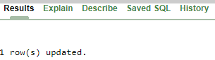
select * from Employees;
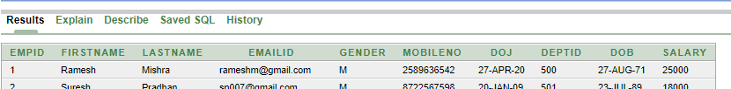

Salary 25000 EmdID - 1

If more than one attribute is to be updated in the row, separate each attribute with commas.

update Employees set MobileNo ='9435681429',

lastname='Bhoi',doj='28=July-19' where Empid =010;
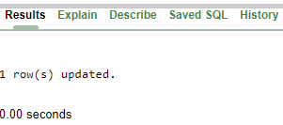

select * from Employees;

MobileNo-9435681429, lastname-Bhoi,doj-28=July-19 EmdID - 10

DELETE

The SQL DELETE Query is used to delete the existing records from a table.
You can use the WHERE clause with a DELETE query to delete the selected rows, otherwise all the records would be deleted.
Syntax:
The basic syntax of the DELETE query with the WHERE clause is as follows:
DELETE FROM table name
WHERE [condition];

delete from Employees where deptid = '507';
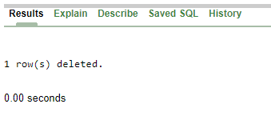

select * from Employees;
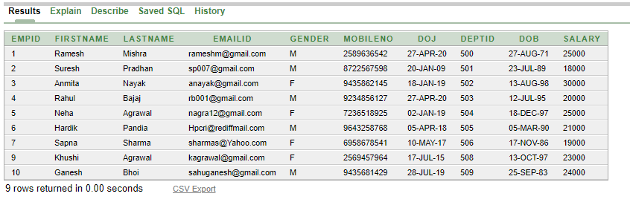

Record DEPTID 507 has DELETED
.

SELECT

- Is a Data Retrieval Language
- SELECT clause specifics the columns to search
- FROM clause specifics the data source
- Column search can be modified using expressions
Syntax:
The basic syntax of the SELECT statement is as follows:
SELECT column1, column2, columnN FROM table name;

Here, column1, column2... are the fields of a table whose values you want to fetch. If you want to fetch all the fields available in the field, then you can use the following syntax.
SELECT * FROM table_name;

select * from Employees;
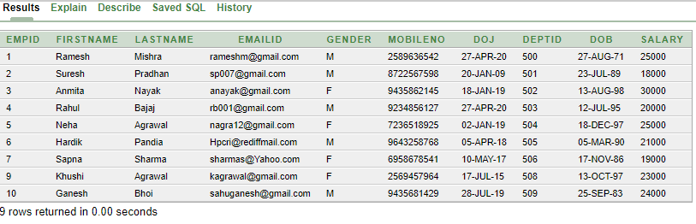

select Empid, Firstname, Lastname, Salary from Employees;
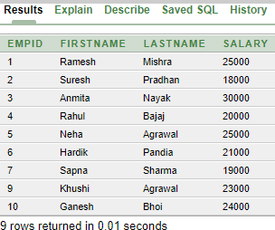

Concatenation Operator
You can link columns to other columns, arithmetic expressions, or constant values to create a character expression by using the concatenation operator (||). Columns on either side of the operator are combined to make a single output column.
In the example,
FIRST NAME and LAST NAME are concatenated, and they are given the alias Employees. Notice that the employee last name and job code are combined to make a single output column.
Literal Character Strings:
Literal strings of free format text can be included in the query result and are treated the same as a column in the SELECT list.
Date and character literals must be enclosed by single quotation marks (' '); number literals need not be so enclosed.
select Empid, firstname || ' ' || lastname, salary from Employees;

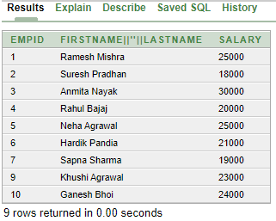

select Empid, firstname || ' ' || lastname, salary*12 from Employees;

SALARY*12
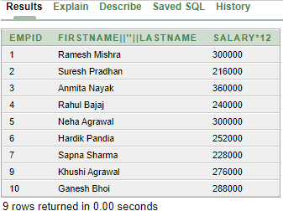c

Column Aliases:
When displaying the result of a query, SQL normally uses the name of the selected column as the column heading. You can change a column heading by using a column alias.
Specify the alias after the column in the SELECT list using a space as a separator. By default, alias headings appear in uppercase. If the alias contains spaces or special characters (such as # or $), or if it is case-sensitive, enclose the alias in double quotation marks (" ").
select Empid, firstname || ' ' || lastname as Employee_Name , salary*12 as Annual_Salary from Employees;

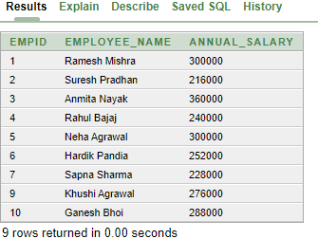

EMPLOYEE_NAME ANNUAL_SALARY

select Empid as "Employee ID", firstname || ' ' || lastname as "Employee Name" , salary*12 as "Annual Salary" from Employees;

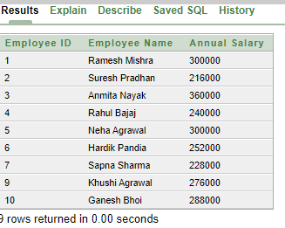
Employee ID Employee Name Annual Salary

DISTINCT keyword : Don’t show the Duplicate Rows

select distinct deptid from Employees;

WHERE Clause

- The WHERE clause is used to add condition to filter.

- Various operators can be used to pass the conditions.

If the given condition is satisfied, then only it returns a specific value from the table.
The WHERE clause is not only used in the SELECT statement, but it is also used in the UPDATE n DELETE statement.

Syntax:

The basic syntax of the SELECT statement with the WHERE clause is as shown below.
SELECT column1, column2, columnN
FROM table_name
WHERE [condition]

You can specify a condition using the comparison or logical operators.

Comparison Operators :

Symbol | Meaning
= | Equal to
< | Less than
<= | Less than or equal to
> | Greater than
>= | Greater than or equal to
<> or != | Not equal to

We will now explore some of these conditional operators using examples.
(In our Employees Table we have 20 records)

select * from Employees;
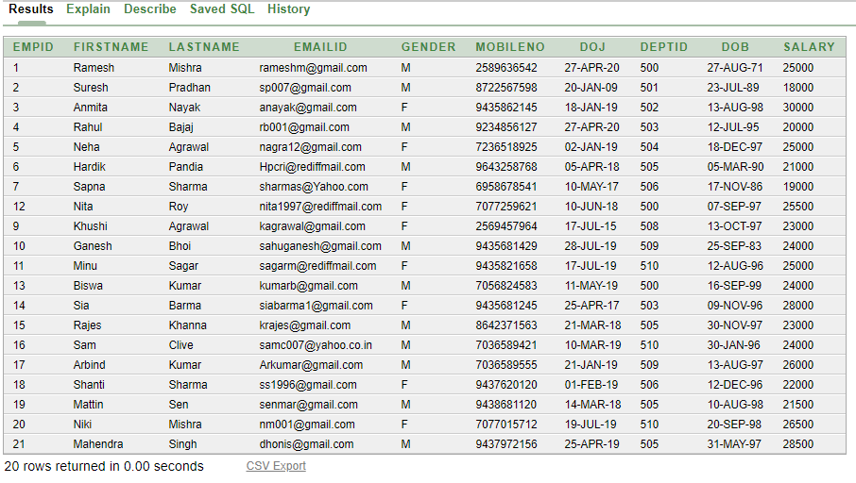

select empid, firstname, lastname, salary, deptid

from employees where deptid = 510;
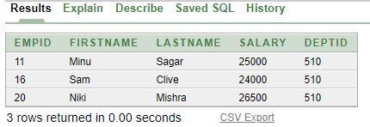

select empid, firstname, lastname, salary, deptid

from employees where deptid != 510;
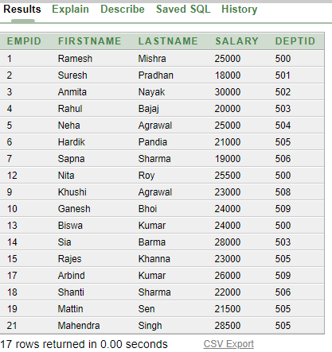

select empid, firstname, lastname, salary, deptid

from employees where salary >=22000;
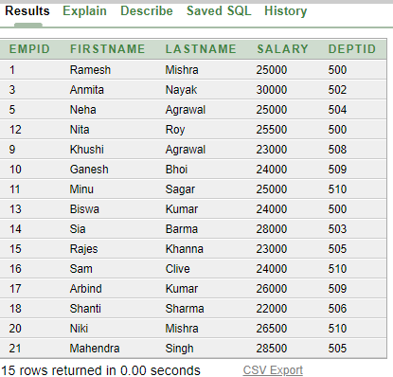

- AND
- OR
- NOT
Logical Operators

AND

For an action to be taken by the SQL statement, whether it be a transaction or a query, all conditions separated by the AND must be TRUE.

select empid, firstname, lastname, salary, deptid

from employees where salary >=25000 and deptid = 505;
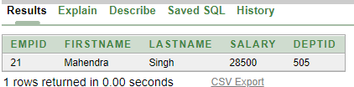

select empid, firstname, lastname, salary, deptid

from employees where salary >=21000 and deptid = 510;
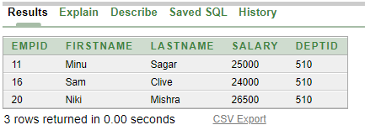

OR
An action to be taken by the SQL statement, whether it be a transaction or query, the only any ONE of the conditions separated by the OR must be TRUE.

select empid, firstname, lastname, salary, deptid,doj
from employees where salary >= 31000 or (doj > '10-jun-2019');

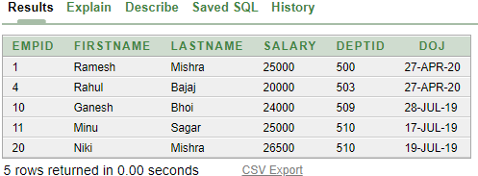

NOT
The NOT operator can also be used with other SQL operators, such as IN, BETWEEN, LIKE, and NULL.

select empid, firstname, lastname, salary,gender

from employees where gender not in 'M';
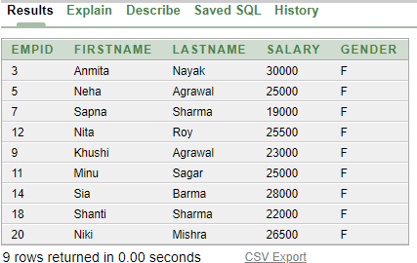

Special Operators
- IN
- BETWEEN ……AND
- LIKE
- IS NOL / IS NOT NULL

IN
The IN operator is used to test for values which are in a list
select empid, firstname, lastname, salary,deptid

from employees where empid in (1,6,8,10,18);
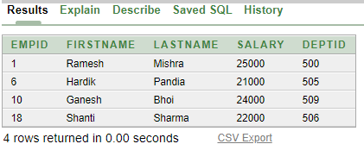

select empid, firstname, lastname, salary,deptid

from employees where empid not in (1,6,8,10,18);
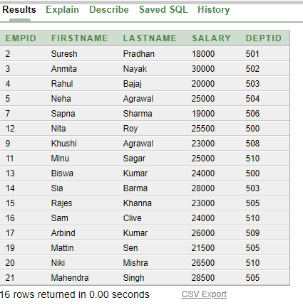

BETWEEN
The operator BETWEEN may be used to check whether an attribute value is within a range of values.

select empid, firstname, lastname, salary,deptid

from employees where salary between 20000 and 23000;
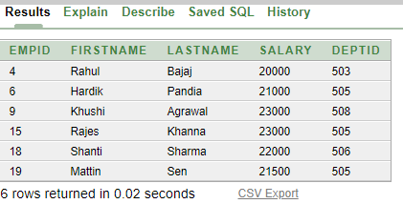

LIKE
The SQL LIKE clause is used to compare a value to similar values using wildcard operators. There are two wildcards used in conjunction with the LIKE operator.
- The percent sign (%)
- The underscore (_)
The percent sign represents zero, one or multiple characters. The underscore represents a single number or character. These symbols can be used in combinations.

select empid, firstname, lastname, salary,deptid

from employees where firstname like 'A%';
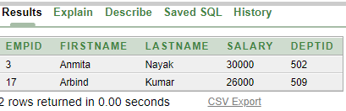

select empid, firstname, lastname, salary,deptid

from employees where firstname like '%S';
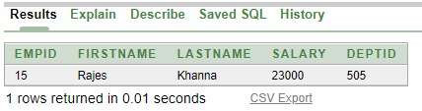

select empid, firstname, lastname, salary,deptid

from employees where firstname like 's____';
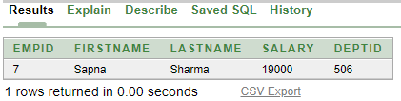

select empid, firstname, lastname, salary,deptid

from employees where salary like '%5__';
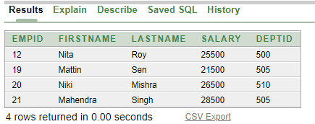

NULL
The NULL conditions include the IS NULL condition and the IS NOT NULL condition.

select empid, firstname, lastname, salary,deptid
from employees where deptid is null;

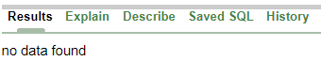

ORDER BY

The SQL ORDER BY clause is used to sort the data in ascending (ASC) or descending (DESC) order, based on one or more columns. Some databases sort the query results in an ascending order by default.
Syntax:
The basic syntax of the ORDER BY clause is as follows:
SELECT column-list
FROM table_name
[WHERE condition]
[ORDER BY column1, column2, .. columnN] [ASC | DESC];

select empid, firstname, lastname, gender, salary

from employees order by salary;
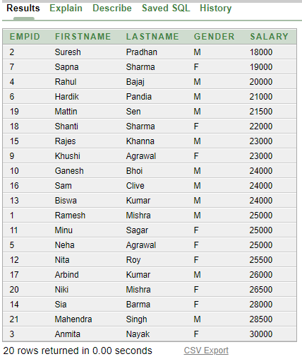

Sorting in descending order:
select empid, firstname, lastname, gender, salary
from employees order by salary desc;

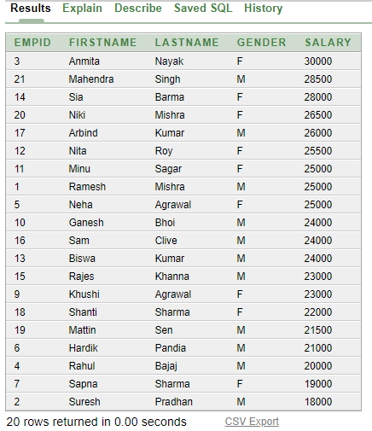

Sorting by column alias:
select empid, firstname, lastname, gender, salary * 12 Annual_Salary from employees order by Annual_Salary;

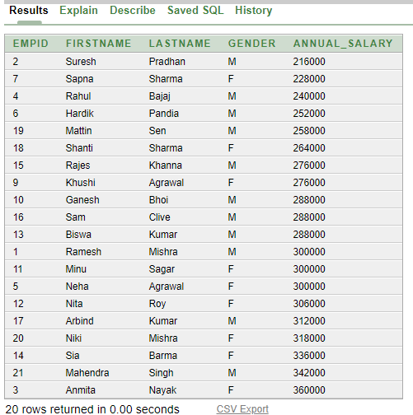

Sorting by multiple columns:
select empid, firstname, lastname, gender, deptid, salary
from employees order by deptid , salary desc;

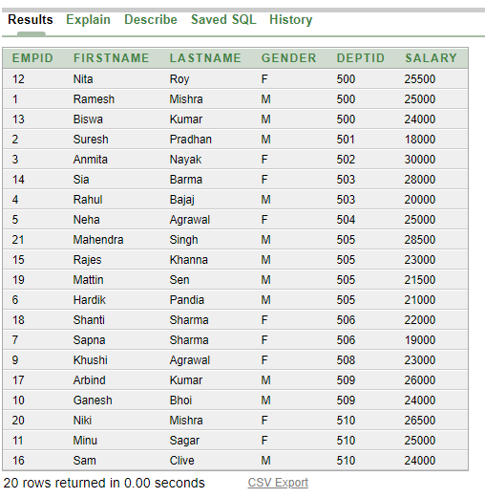

select empid, firstname, lastname, gender, deptid, salary
from employees order by salary desc,firstname ;

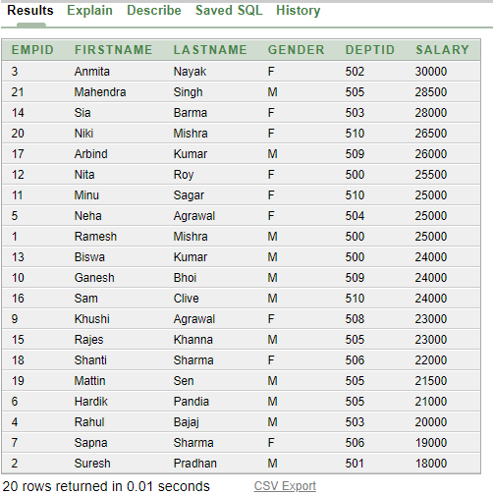

select empid, firstname, lastname,dob, salary
from employees order by dob ;

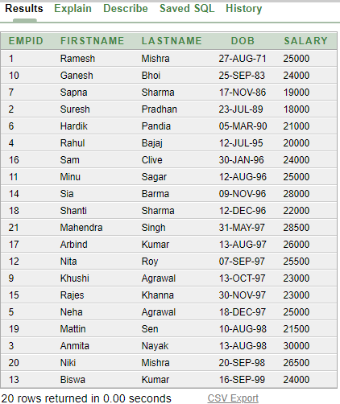

select empid, firstname, lastname, gender, deptid, salary
from employees order by firstname;

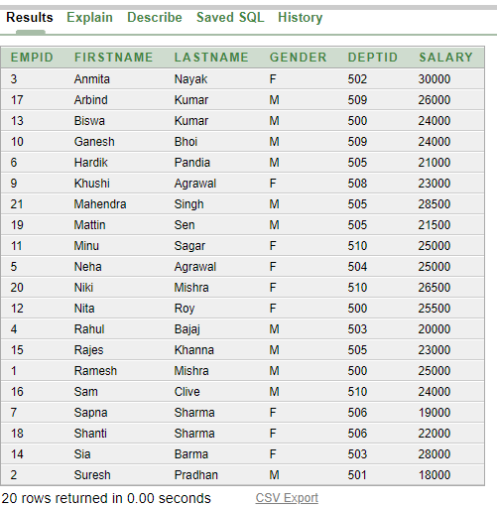

select empid, firstname, lastname, gender, deptid, salary

from employees order by 3;
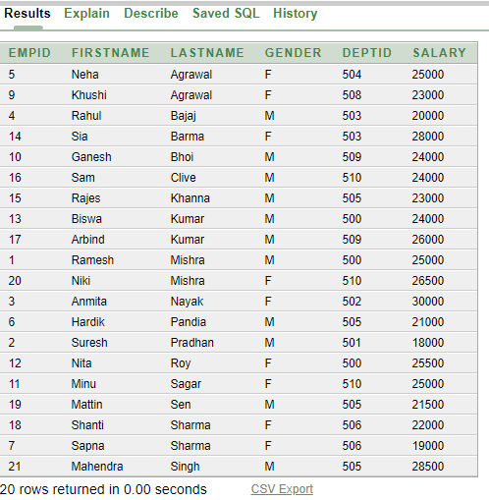

SQL Functions

Functions are a very powerful feature of SQL. They can be used to do the following:
  - Perform calculations on data
  - Modify individual data items
  - Manipulate output for groups of rows
  - Format dates and numbers for display
  - Convert column data types
  - Accept the values through parameters
  - Return the processed value

Two Types of SQL Functions :-
- Single-row function

- Multiple-row function

Single-row function
Single-row functions are used to manipulate data items. They accept one or more arguments and return one value for each row that is returned by the query. There are different types of single-row functions.
- Character functions
- Number functions
- Date functions
- Conversion functions
- General functions
Character functions :
Accept character input and can return both character and number values. Character functions can be divided into the following:
- Case-manipulation functions
Function | Purpose
LOWER(column|expression) | Converts alpha character values to lowercase
UPPER(column|expression | Converts alpha character values to uppercase
INITCAP(column|expression | Converts alpha character values to uppercase for the first letter of each word; all other letters in lowercase

Function | Purpose
LENGTH(column|expression) | Returns the number of characters in the expression
CONCAT(column1|expression1,  column2|expression2) | Concatenates the first character value to the second character value; equivalent to concatenation operator (||)
SUBSTR(column|expression,m[ ,n] | Returns specified characters from character value starting at character position m, n characters long (If m is negative, the count starts from the end of the character value. If n is omitted, all characters to the end of the string are returned.)
RPAD(column|expression,n, ‘string') | Pads the character value left-justified to a total width of n character positions
LPAD(column|expression,n,'string') | Pads the character value right-justified to a total width of n character positions
- Character-manipulation functions

select empid , firstname , lastname , deptid from employees where lastname = 'Sharma';

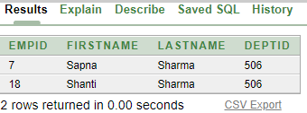

select empid , firstname , lastname , deptid from Employees where lastname = 'SHARMA';

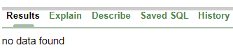

select empid , firstname , lastname , deptid from Employees where lower(lastname) = 'sharma';

37

select empid , upper(firstname) , lower(lastname) , deptid from Employees where lower(lastname) = 'sharma';

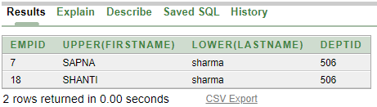

select initcap('somadarshi nayak') from dual;
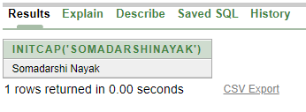

select empid , upper(firstname) , lastname , deptid from Employees where length(firstname) = 6;

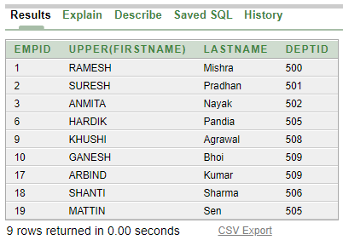

select Firstname , length(Firstname) as NAMESIZE FROM Employees;
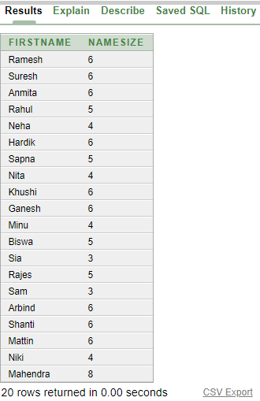

select empid , concat(firstname , lastname) , deptid from Employees where length(firstname) = 6;

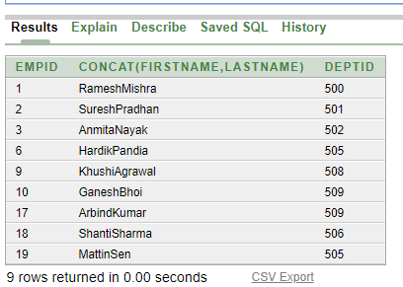

select firstname , lastname ,substr(mobileno,1,3) from Employees where length(firstname) = 6;

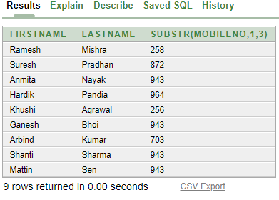

select firstname , lastname ,rpad(substr(mobileno,1,3),10,'x') as Mobile_No from Employees where length(firstname) = 6;

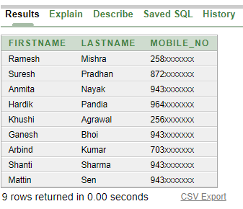

select firstname , lastname ,lpad(substr(mobileno,8,3),10,'x') as Mobile_No from Employees where length(firstname) = 6;

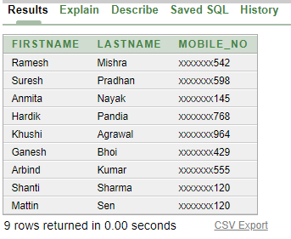

Q: - Write a query which generates a list of employee user IDs, using first the day of the month they were born and then the first six characters of their last name in UPPER case.
select Firstname , lastname,concat(substr(dob,1,2), upper(substr(lastname,1,6))) as User_ID from Employees;

